

**Final Report**

**Center : hungvuong aptech**

**E roject : doctor information system**

**Team ‘s members :**

**-Nguyen tan cong**

**-Tran hoang anh**

**-Doan hoang de**

**-Pham duc phuc**

**1/Project Plant :**

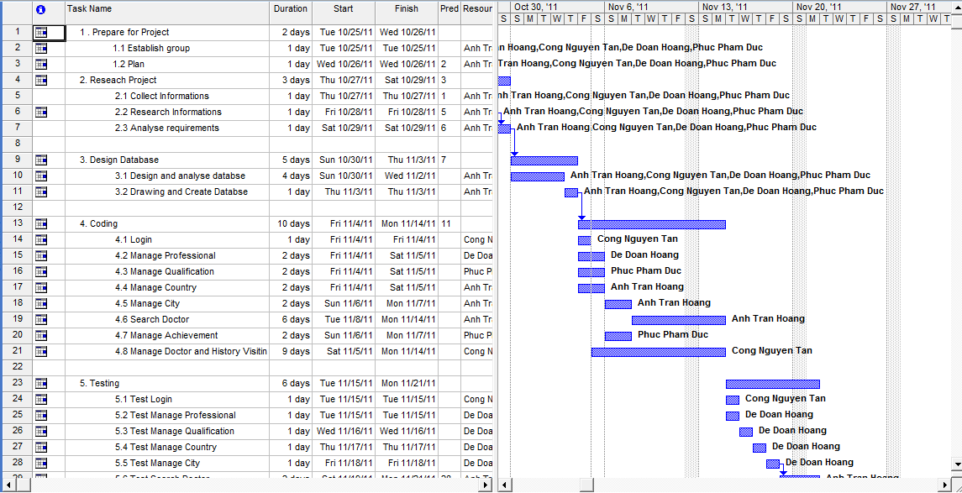

**2/use case diagram:**

2.1 image

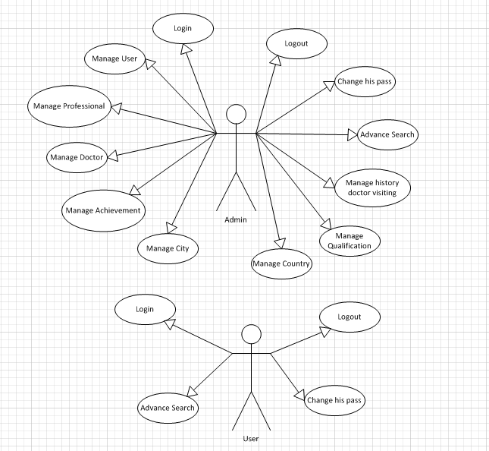

2.2/ List of Actors

|  |  |  |
| --- | --- | --- |
| No. | Actors | Comment |
| 1 | Admin | Manage system |
| 2 | Users | Manage information system |

2.3/ List of User-Case

|  |  |
| --- | --- |
| No. | User-Case |
| 1 | Login |
| 2 | Add User |
| 3 | Manage professional |
| 4 | Manage Doctor |
| 5 | Manage Achievement |
| 6 | Change pass |
| 7 | Advance Search |
| 8 | Logout |
| 9 | Manage city |
| 10 | Manage country |
| 11 | Manage qualification |
| 12 | Manage history doctor’ visiting |

2.4/ Description

2.4.1 / Login

|  |  |
| --- | --- |
| Use Case | Login |
| Summary | Allows user login to system with corresponding powers |
| Major Events : | Step 1 : When user start application form login will be displayed  Step 2 : User enter their Username and Password  Step 3: Press button “Login” program will check Username and Password in database.  Step 4 : If exist program will display a confirmation message “Login Successful”  Else program will display a confirmation message “Login Failed”  Step 5 : User press button “Exit” to exit this form |

2.4.2 / Manage User

|  |  |
| --- | --- |
| Use Case | Manage User |
| Summary | User management |
| Major Events : | Sep1: If the login is admin. From admin will appear  Setp2: Manage User, Add User, Delete User, Role is Admin or User.  Setp3:If successfully implemented in the "success " , failed in an error "error " |

2.4.3/ Manage Professional

|  |  |
| --- | --- |
| Use Case | Manage Professional |
| Summary | Present Professional. |
| Major Events: | Step1: Professional from out. Manage Professional.  Step 2:if the admin login ,Add new Professional, delete Professional, update Professional.  Step3: When successfully implemented, print "success ". Upon failure, print "error ". |

2.4.4/ Manage Doctor

|  |  |
| --- | --- |
| Use Case | Manage Doctor |
| Summary | Present Doctor. |
| Major Events: | Step1: Doctor from out. Manage doctor.  Step 2: if the admin login , add doctor, delete doctor , update doctor.  Step3: When successfully implemented, print "success ". Upon failure, print "error ". |

2.4.5/ Manage Achievement

|  |  |
| --- | --- |
| Use Case | Manage Achievement |
| Summary | Present Achievements. |
| Major Events: | Step1: Achievement from out, manage Achievement.  Step 2: if the admin login, add achievement, delete achievement, update Achievement.  Step3: When successfully implemented, print "success ". Upon failure, print "error ". |

2.4.6/Advance Search

|  |  |
| --- | --- |
| Use Case | Search |
| Summary | Search engine rankings faster |
| Major Events: | Advance Search for( Doctor name, Professional name, qualification, location, achievement, visiting time, experience years)  press the Enter key begins search |

2.4.7/ Change pass

|  |  |
| --- | --- |
| Use Case | Change pass |
| Summary | Make more secure passwords |
| Major Events: | Step1: Change pass from out.  Step2: when press Ok if successful. Cancel button if you want the most satisfactory.  Step3: When successfully implemented, print "success ". Upon failure, print "error ". |

2.4.8/ Logout

|  |  |
| --- | --- |
| Use Case | Logout |
| Summary | Help user logout the program |
| Major Events: | Step 1 : When user want to out click "Logout" on the program interface  Step 2: Program will display a confirmation message “Do you want to sign out”  Step 3 : If click “Yes” user will exit program and disconnect with database  If click “No” user will turn back application interface |

2.4.9/ Manage City

|  |  |
| --- | --- |
| Use Case | Manage City |
| Summary | Present City. |
| Major Events: | Step1: Professional from out. Manage City.  Step 2:if the admin login ,Add new City, delete city, update city.  Step3: When successfully implemented, print "success ". Upon failure, print "error ". |

2.4.10/ Manage country

|  |  |
| --- | --- |
| Use Case | Manage country |
| Summary | Present country. |
| Major Events: | Step1: country from out. Manage country.  Step 2:if the admin login ,Add new country, delete country, update country.  Step3: When successfully implemented, print "success ". Upon failure, print "error ". |

2.4.11/ Manage Qualification

|  |  |
| --- | --- |
| Use Case | Manage Professional |
| Summary | Present Qualification. |
| Major Events: | Step1: Qualification from out. Manage Qualification.  Step 2:if the admin login ,Add new Qualification, delete qualification, update qualification.  Step3: When successfully implemented, print "success ". Upon failure, print "error ". |

2.4.12/ Manage history doctor’ visiting

|  |  |
| --- | --- |
| Use Case | Manage history doctor’ visiting |
| Summary | Present history doctor’ visiting. |
| Major Events: | Step1: history doctor’ visiting from out. Manage history doctor’ visiting.  Step 2:if the admin login ,Add new record, delete record, update record.  Step3: When successfully implemented, print "success ". Upon failure, print "error ". |

**3/ Database diagram :**

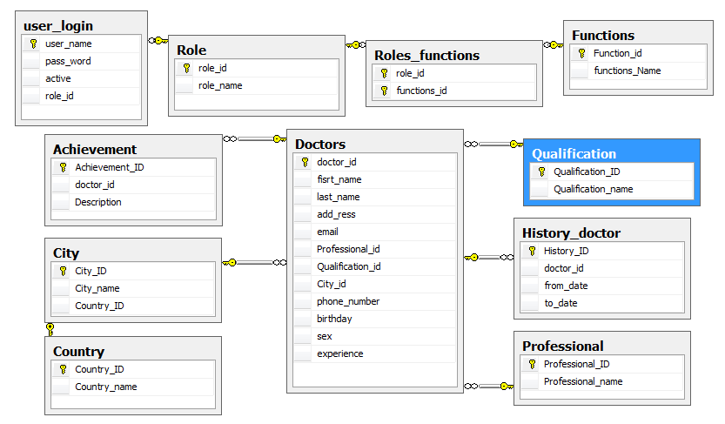

**Database diagram**

**3.1.user_login : Table**

|  |  |  |
| --- | --- | --- |
| **Name** | **Data style** | **Description** |
| user_name(PK) | varchar(40) | User name |
| Pass_word | varchar(20) | User’ password |
| Active | int | User status |
| Role_id | int | User role |

**3.2.** **History_doctor : Table( w**hovisit the hospital on some week days**)**

|  |  |  |
| --- | --- | --- |
| **Name** | **Data style** | **Description** |
| History_ID(PK) | int | history id |
| Doctor_id | int | Doctor id |
| From_date | smalldatetime | Coming date |
| To_date | smalldatetime | Out date |

**3.3.** **Professinal : Table**

|  |  |  |
| --- | --- | --- |
| **Name** | **Data style** | **Description** |
| Professtional_ID(PK) | int | Professtional id |
| Professtional_name | varchar(40) | Professtional name |

**3.4.** **Qualification : Table**

|  |  |  |
| --- | --- | --- |
| **Name** | **Data style** | **Description** |
| Qualification_ID(PK) | int | Qualification id |
| Qualification_name | varchar(40) | qualification name |

**3.5.** **Country : Table**

|  |  |  |
| --- | --- | --- |
| **Name** | **Data style** | **Description** |
| Coutry_ID(PK) | int | Country id |
| Country_name | varchar(40) | Country name |

**3.6.** **City : Table**

|  |  |  |
| --- | --- | --- |
| **Name** | **Data style** | **Description** |
| City_ID(PK) | int | City id |
| City_name | varchar(40) | City name |
| Country_id | int | Country id |

**3.7. Doctor : Table**

|  |  |  |
| --- | --- | --- |
| **Name** | **Data style** | **Description** |
| Doctor_ID(PK) | int | Login id |
| First_name | varchar(40) | Doctor’ firstname |
| Last_name | varchar(40) | Doctor’ lastname |
| Add­_ress | varchar(50) | Doctor’ home address |
| Email | Varchar(40) | Doctor’ email |
| Professtional_id | int | Doctor’ professtional id |
| Qualification_id | int | Doctor’ qualification id |
| City_id | int | Location id |
| Phone_number | varchar(25) | Doctor’ number phone |
| Birthday | smalldatetime | Day of birth |
| sex | varchar(6) | gender |
| experience | int | Experience years |

**3.8.** **Achievement : Table**

|  |  |  |
| --- | --- | --- |
| **Name** | **Data style** | **Description** |
| achievement_ID(PK) | int | Achievement id |
| Doctor_id | int | Doctor id |
| desciption | varchar(255) | Describe doctor achievement |

**3.9.** **role_id : Table**

|  |  |  |
| --- | --- | --- |
| **Name** | **Data style** | **Description** |
| Role_ID(PK) | int | role id |
| Role_name | Varchar(40) | Role name |

**3.10.** **role_functions : Table**

|  |  |  |
| --- | --- | --- |
| **Name** | **Data style** | **Description** |
| Role_ID(PK) | int | Role id |
| Functions_id(PK) | int | Functions id |

**3.11.** **functions : Table**

|  |  |  |
| --- | --- | --- |
| **Name** | **Data style** | **Description** |
| functions_ID(PK) | int | functions id |
| functions_name | int | Functions name |

**4 . SITE MAP**



1. **FLOW CHART**

**LOGIN**



* 1. **LOG OUT**



ADVANCE SEARCH



CHANGE PASSWORD



**Manage achievement**



**Manage city**



**Manage country**



**Manage doctors**



**Manage history doctor**



**Manage professional**



**Manage qualification**



**Manage user**



1. **Interface System**

**Form Login:**

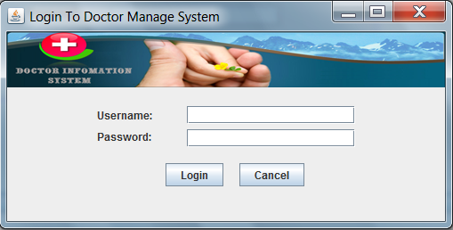

**Main Form:**

**Administrator:**

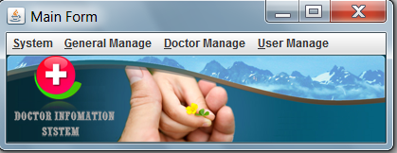

**Employee:**

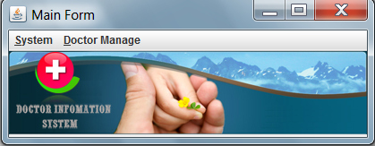

**Manage Doctor Form:**

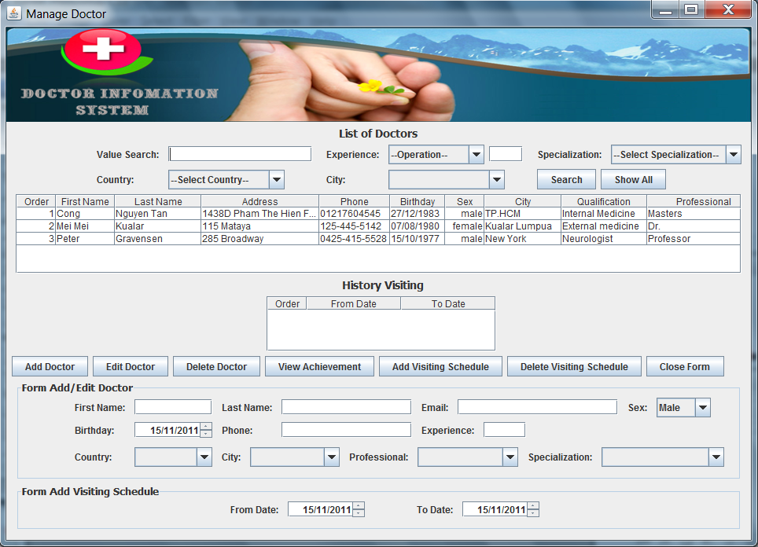

**Manage achievement form :**

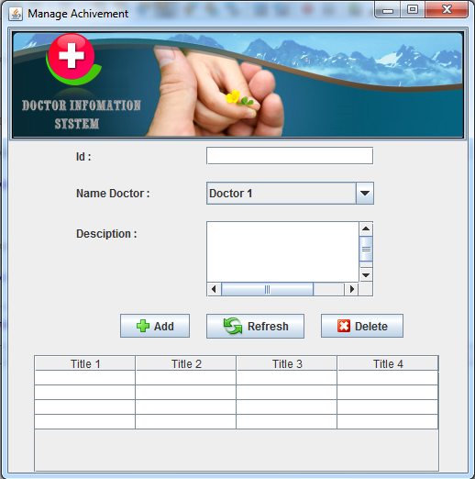

**Manage qualification form :**

